Lorain Metropolitan Housing Authority Housing Counseling Work plan

TARGET COMMUNITY:
The Lorain Metropolitan Housing Authority (LMHA) is located in the city of Lorain, Lorain County, Ohio. LMHA manages 1,438 Public Housing Units in Lorain, Elyria, Oberlin and Amherst, Ohio. LMHA also manages two elderly/disabled high-rises under the Section 8 New Construction sector, consisting of 100 units in Elyria and 100 units in Lorain. LMHA administers 3,129 Housing Choice Vouchers throughout Lorain County.

Our target population are the Housing Choice Voucher Program participants in Lorain County. Currently, housing counseling is offered to participants that have been determined eligible according to the LMHA Administrative Plan.

The cities of Lorain and Elyria are the county’s two largest cities. Their populations are 64,028 and 53,881 respectively and represent 39% of the County’s population. According to 2018 Census data, there are approximately 309,461 residents of Lorain County. This area’s characteristics include an average median income of $54,987, with a population comprised of 86.4% White, 8.9% African American and 10% Hispanic.

Lorain County in 2018 had a population of 309,461 with 54.2% of the population ages 19-64. The population of the area is 86.4% white with 89.5% having at least a high school diploma. The median household income for the area in 2018 was $54,987 yielding 13.5% of the population at or below poverty level. Approximately 28.6% of Lorain County are renters. For the cities of Lorain and Elyria, those numbers are 43.2% and 40.6% respectively. The median value of an owner-occupied housing unit in Lorain County is $140,300. The median gross rent from 2013 – 2017 is $751.

LMHA began offering Pre-purchase Homebuyer Education Workshops and Pre-Purchase housing counseling in 2002 for the purpose of offering HCVP Participants an opportunity to participate in the LMHA Home Ownership Option Program. In addition, there is one other agency that provides Pre-Purchase housing counseling (Lorain County Urban League) in all of Lorain County.
Attached is a list of all zip code areas of the target population and a map of LMHA’s service area.

Housing Needs and Problems:
As stated previously, approximately 28.6% of Lorain County are renters. For the cities of Lorain and Elyria, those numbers are 43.2% and 40.6% respectively.

According to a report published by the Housing Finance Policy Center in November 2017 entitled Barriers to Accessing Homeownership, barriers include down payment, credit and affordability. Over 50% of renters state that down payments are a barrier to owning a home. The median credit score of new purchase mortgage originations has increased considerably in the post-crisis period. The median credit score for purchase mortgages is 779, compared with the pre-crisis median of 692. Credit scores of FHA borrowers have historically been lower; the current median credit score is 671. While lower down payments reduce barriers to purchasing a home, they can also increase monthly payments. A metric for determining affordability is based on the median family income. Lorain County’s median income is $54,987 with Lorain and Elyria median family income is $36,139 and $42,067 respectively. The poverty rate for Lorain County is 13.5%; and 25.4% and 21.1% for Lorain and Elyria.

According to LMHA’s Annual Plan, at the end of the calendar year 2018, more than 88% of applicants for LMHA’s housing programs were at or below the Extremely Low Income (ELI) level. Approximately 86% of public housing residents, 88% of multifamily residents and 78% of participants of the HCVP are ELI. For comparison, approximately 15% of families in Lorain County are ELI.

All of this information results in the identification of three major housing problems –
- need for financial literacy and education for low-to-moderate income families;
- need for both short term and long term pre-purchase counseling; and
- post purchase counseling to continue to connect families with resources and reduce loan default.

HOUSING COUNSELING SERVICES:

Our agency offers the HCVP Homeownership Option Program. LMHA has been approved for the following types of housing counseling in accordance with this counseling work plan:

- Financial Management/Budget Counseling
This includes but is not limited to: credit counseling; credit repair; budgeting, annual income and expenses and affordability;

- Fair Housing Pre-Purchase Education Workshops
This includes but is not limited to: identifying state and local resources for fair housing enforcement; reporting violations; understanding rights and promote client’s awareness of fair housing;

- Mortgage Delinquency and Default Resolution Counseling
This includes but is not limited to: understanding how to avoid foreclosure; retention strategies and repayment plans, forbearance agreements, loan modifications or other loss mitigation options; identifying mortgage default scams and financial management and budgeting.

- Non-Delinquency Post-Purchase and Default Resolution Counseling
This includes but is not limited to: loan and grant options; housing codes and home improvement; utility costs; energy efficiency; escrow funds; budgeting; refinancing; home equity and other forms of financial management after the purchase of the home.

- Pre-Purchase Counseling
This includes but is not limited to: determining if homeownership is right for the client; establishing affordability; helping clients understand their rights; shopping for a home; making an offer; obtaining financing and homeowners insurance; closing on the home and learning the terminology and the key home-buying professionals that they will work with.

- Pre-Purchase Homebuyers Education Workshops
This includes but is not limited to: advice regarding readiness and preparation for homeownership; Federal Housing Administration insured financing; housing selection and mobility; search assistance; fair housing, fair lending and predatory lending; budgeting and credit; loan product and feature comparison; purchase procedures and closing costs; money management (does not include debt management plan programs); selecting a real estate agent; and home inspection. This may also include guidance on alternative sources of mortgage credit; down payment assistance; locating housing that provides universal design and visibility; how to apply for special programs available to potential homebuyers; how to purchase a home using the HCVP Homeownership Program and referrals to community services and regulatory agencies.

- Predatory Lending Education Workshops
This includes but is not limited to: abusive and predatory lending practices; loan scams; mortgage regulations and lender disclosures

- Resolving/Preventing Mortgage Delinquency Workshops
This may include but is not limited to the consequences of default and foreclosure; loss mitigation, budgeting and credit; and obtaining re-certification for mortgage subsidy. It may also include helping clients affected by predatory lending; foreclosure prevention strategies; explaining the foreclosure process; providing referrals to other sources and assisting clients with locating alternative housing.

Process for One-on-one Counseling:
- Intake: The application form is completed by the client and reviewed at the beginning of the meeting with the counselor. It is at this time that the client will receive all pertinent forms to complete and return. This includes the home inspection materials as stated below in accordance with the following websites: https://files.hudexchange.info/resources/documents/Housing-Counseling-New-Certification-Requirements-FAQs.pdf; https://www.hud/gov/sites/dfiles/OCHCO/documents/9900.pdf; https://www.hudexchange.info/programs/housing-cousneling/webinars/. A copy of the forms will be retained in the file.
  - All required documents are completed at this time
  - Forms are maintained in the client file
    - Intake Form
    - Privacy Policy and Practices Form
    - Housing Counseling Program Disclosure
    - Fair Housing Rights & Responsibilities
    - Policy on Conflict of Interest
    - HUD-Form 92564-CN, For Your Protection; Get a Home Inspection & Ten Important Questions to Ask Your Home Inspector

- Action Plan: At the first meeting an action plan is developed including the following:
  - Goals including any issues that must be resolved
  - Steps for reaching goals and who will be responsible for each step
  - Estimated timeframe for steps

- Financial Analysis:
  - Obtain and verify a budget
  - Discuss ways to save money and cut expenses
  - Develop a budget that the client can afford
  - Review client-supplied credit report; if applicable
- Follow-Up:
  - LMHA makes reasonable efforts to have follow-up communication with the client, to assure that the client is progressing toward his or her housing goal, to modify or terminate housing counseling, and to learn and report outcomes. The client follow-up is conducted by a qualified housing counselor who makes reasonable efforts to conduct a verbal (in person or via phone) follow- up session within the first 60 days of no client contact. If unsuccessful, after two attempts to conduct a verbal follow-up session, the counselor writes a letter or sends an e-mail to the client stating that such efforts have been made and informs the client that there is a need for follow-up communication. The letter requests that the client contact the housing counseling agency no later than 30 days from the date of the letter, to help the agency assess if additional client services are necessary to assist them in achieving their housing goals or if services should be terminated.

- Termination:
  - Client file will be terminated based on HUD’s seven outcomes when the client’s issue is resolved, goal is met, or the following follow-up yields the need to terminate.

EDUCATION WORKSHOPS:

PRE-PURCHASE EDUCATION:

Financial Literacy and Pre-Purchase Homebuyers Training

- Offer pre-purchase workshop three to four times per year at the LMHA office located at 1600 Kansas Ave, Lorain OH 44052. The classes can be held on two Saturdays from 10am to 4:30pm or two days during the week from 9am to 3:30pm.
- Interested parties call to reserve a seat but we accept walk-ins.
- Education workshop curriculum includes information covering the following topics:
  - Home maintenance (including care of the grounds);
  - Budgeting and money management;
  - Credit Counseling;
  - How to negotiate the purchase price of a home;
  - How to obtain homeownership financing and loan pre-approvals, including a description of types of financing that may be available, and the pros and cons of different types of financing;
  - How to find a home, including information about homeownership opportunities, schools and transportation in the PHA jurisdiction;
  - Advantages or purchasing a home in an area that does not have a high concentration of low-income families and how to locate homes in such areas;
  - Information on fair housing, including fair housing lending and local fair housing enforcement agencies; and
  - Information about the Real Estate Settlement Procedures Act (12 U.S.C. 2601 et seq.) (RESPA), state and Federal truth-in-lending laws and how to identify and avoid loans with oppressive terms and conditions.
- Individual counseling may cover any of the topics described above plus any additional topics as needed by potential homebuyers:
  - Renting vs Buying
  - Improving financial behavior
  - Pre-Qualifying
  - Credit and Debit Management and Repairing Credit
  - Handling Identity Theft
  - Consumer Protection Acts
  - Key Terminology
  - Home Inspection
- Follow-up
  - Interested parties have the option of signing up for one-on-one counseling at the group education workshops.
  - Housing Counselor will reach out to attendees two (2) additional times
- Anticipate that client will be able to understand contract and closing documents and process to purchase a home

Referrals to other agencies and community resources:
  - List of referrals include, but not limited to:
    - Legal Aid Society of Greater Cleveland
    - Lorain County Community Action Agency
    - Ohio Means Jobs
    - Neighborhood Housing Services of Greater Cleveland
    - Ohio Housing Finance Agency
    - Goodwill Job Club
    - Lorain County Urban League
    - 211 – United Way
    - Consumer Financial Protection Bureau
    - Ohio Civil Rights Commission
    - Lorain County Dept of Job & Family Services

Record Keeping:

On-Line
- Client Management System (CMS) software is used to track the client and store information
- The online program is password protected and only authorized users have access to the program. LMHA utilizes CounselorMax.

Hard Copy Files, if applicable:
- A central file for each client will be used to store hard copies. Files are stored in a secure filing cabinet.
- All meetings and phone calls with the client are logged.
- Any letters, correspondence, or copies of client documents (loan docs, etc.) to or on behalf of the client are kept in their confidential file.

Individual File documentation includes:
- File Number
- Date activity occurred
- Length of session
- Name of housing counselor
- Client’s name, address and phone number
- FHA case number if applicable
- Client Action Plan
- Intake Form information
- Financial Analysis
- Disclosure/Conflict of Interest statements given to client
- Alternatives discussed
- Log of activities performed on behalf of the client (stored online)
- Required data elements are kept in the on-line system
- Copies of pertinent records and correspondence
- Type of housing counseling received Follow Up Activities
- Termination Date (date client file closed and reason for termination)

Group Files Documentation Includes:
- File Number
- Attendees Name (First and Last)
- Attendees Address (City, state and zip code)
- Attendees Phone number
- Attendee Race
- Attendee Ethnicity
- Attendee Income Level (annual)
- Attendee Referred by
- Attendee First Time Home Buyer (yes or no)
- Signature of each client
- Amount of fee charged, if applicable
- Date, duration and location of workshop
- Counselor and/or Instructors
- Workshop Subject
- Conflict of Interest Statement

Credit Reports and Confidentiality:
- All credit files should be kept in a locked filing cabinet along with other supporting documentation such as tax returns, paystubs and any forms with social security numbers. The application and demographic information completed on the client and the client housing counseling plan should be documented in the CMS system.
- Both computer and hard copies of logs (optional for hard copies) are kept and include the required information
- Each Counselor has their own pass code to enter their client files on the computer
- All printed information is kept in client files in a locked
- All one-on-one credit counseling is done in a private area

Conflict of Interest: LMHA will provide all clients with information that they are free to obtain housing counseling from the agency of their choice. The information is printed on our material so all potential clients receive it. We also include a statement as part of their authorization materials.

“The counseling services, affordable housing and other forms of assistance that may be offered by LMHA its subsidiaries, affiliates or directors, officers, employees, agents or partners may also be offered by other providers and you are under no obligation to utilize services from LMHA, regardless of the recommendations made by counselors.”

Supervisory Monitoring and Documentation for Quality Control Plan Compliance:
It is the intent of the Lorain Metropolitan Housing Authority (LMHA) to deliver the highest quality financial literacy home buyers education classes.

To do that, LMHA has put the following monitoring and quality control steps into place:

- The classes are currently held quarterly, or three to four times per year. The classes consist of 11 hours of financial literacy/homebuyers education training which are divided into two sessions. The HCVP Manager will randomly attend a session or sessions of the counseling classes without prior notice to the instructor/counselor to monitor the accuracy and delivery of information provided to the clients.

- Once the class has been selected and monitored, the HCVP Manager will discuss findings in the following manner:

  - Complete a review of the class with the counselor, including positive results and any constructive criticism
  - Determine if there were any discrepancies
  - Discuss and determine corrective measures
  - Conduct a follow-up review of the class with the counselor after corrective measures are initiated.

- The HCVP Manager shall randomly select group session folders to review to ensure each file has the required file number and documentation.

- The HCVP Manager shall randomly select files from one-on-one counseling sessions to ensure each file is properly labeled and that all required documentation and counseling steps are included in the file.

- The HCVP Manager will discuss findings with the counselor.

LIMITED ENGLISH PROFICIENCY:
LMHA’s plan serves non-English speaking or clients with limited English proficiency. In accordance with our Language Access Plan, we provide access to program benefits and information to LEP individuals through language assistance services at no cost to the client. The agency has employees that speak Spanish. Translators will be hired to accommodate other languages which might be needed. Some documents may be available in Spanish, and a translation of other languages can be provided as needed.

ALTERNATIVE SETTINGS/FORMAT:
LMHA’s main office is ADA accessible. However, LMHA acknowledges that there may be circumstances where clients will need special accommodations. Therefore, the agency will provide a person with disabilities counseling in an alternative format or make arrangements to meet at an alternative location as a reasonable accommodation to the person’s disability. Face-to-face, phone and secure internet, skype, virtual and video counseling are all appropriate alternatives and the counselor will use the setting and format that works best for the client.

FEE STRUCTURE:
LMHA provides all clients with the necessary educational materials required to complete one-on-one counselling and group training classes. Participants are not currently charged a fee for either of these services.

AFFIRMATIVELY FURTHER FAIR HOUSING:

The Consolidated Plan for the City of Lorain lists cost burden, substandard housing and severely over-crowded housing as housing problems. It states “A disproportionately greater need exists when the members of racial or ethnic group at an income level experience housing problems at a greater rate (10% or more) than the income levels as a whole. For example, assume that 60% of all low-income households have a housing problem. In this case, low-income Hispanic households have a disproportionately greater need.” Based on their study, White households have the highest number of households (1,930) with housing problems (80% of all White households earning 0-30% AMI) and African-American households have the second-highest number of households (1,155) with housing problems (70% of all African-American household earning 0-30% AMI). When considering ethnicity and this income category, 1,330 Hispanic households have housing problems (79% of all Hispanic households earning 0-30% AMI).

An effective and HUD-approved approach to creating fair housing is to improve opportunities with these low-to-moderate income areas where more protected persons live, as a consequence of affordability issues. Based on this recommendation, both the city of Elyria and Lorain have implemented activities that include neighborhood revitalization through rehabilitation, purchase/rehab/resale, enhancement of recreational facilities, education and employment training opportunities geared to these areas, down payment assistance and homebuyer counseling programs already underway. Utilizing the systemic and complaint-based testing in the county, the two major cities including the county as a whole will continue to partner annually with LMHA and other qualified agencies to conduct testing and any required follow-up (City of Elyria Fair Housing Impediments, Strategies and Timelines, 2012).

MARKETING AND OUTREACH:
LMHA will market the Homeownership Option Program on an annual basis to all Housing Choice Voucher Program participants. LMHA will market quarterly to all newly eligible families. These are families who have been in their assisted homes for the past 12 months. LMHA utilizes social media, such as Facebook, and the LMHA website at www.lmha.org to reach families interested in participating in the Homeownership Option Program. LMHA makes flyers available in the lobby and includes them in HCVP mailings. LMHA employees market programs during networking opportunities and at partnering agency meetings.

Housing Counseling Certification Requirements
The agency housing counseling work plan must be updated to reflect new requirements under HUD’s Final Rule for Housing Counseling Certification effective January 13, 2017. Under this rule, any agency providing homeownership counseling (pre-purchase, post-purchase non-delinquency, mortgage delinquency/default, or reverse mortgage (HECM) counseling) must cover the following topics: the decision to purchase a home, the selection and purchase of a home, issues arising during or affecting the period of ownership of a home (including financing, refinancing, default, and foreclosure, and other financial decisions) and the sale or other disposition of a home. The agency must also provide required home inspection materials to all clients expressing interest in purchasing a home.

The agency’s work plan must outline how the agency is prepared to address the components of the process of homeownership that are relevant to each client’s individual needs and circumstances or if the client has requested information on those components. The agency’s work plan must also describe when in the Homeownership Counseling process, the client will receive home inspection materials and how the agency will document compliance with this requirement.
Reference: HUD Final Rule for Housing Counseling Certification published December

_____________________________________________ ___________________________
Signature Date

_Homer A. Virden, Executive Director____________
Print Name & Title

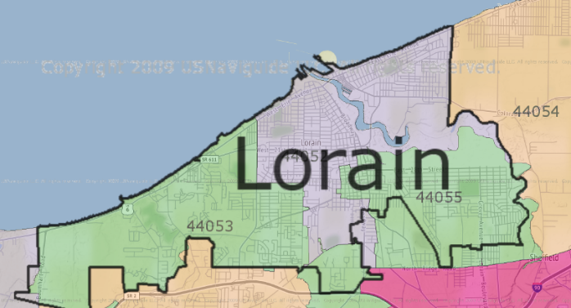
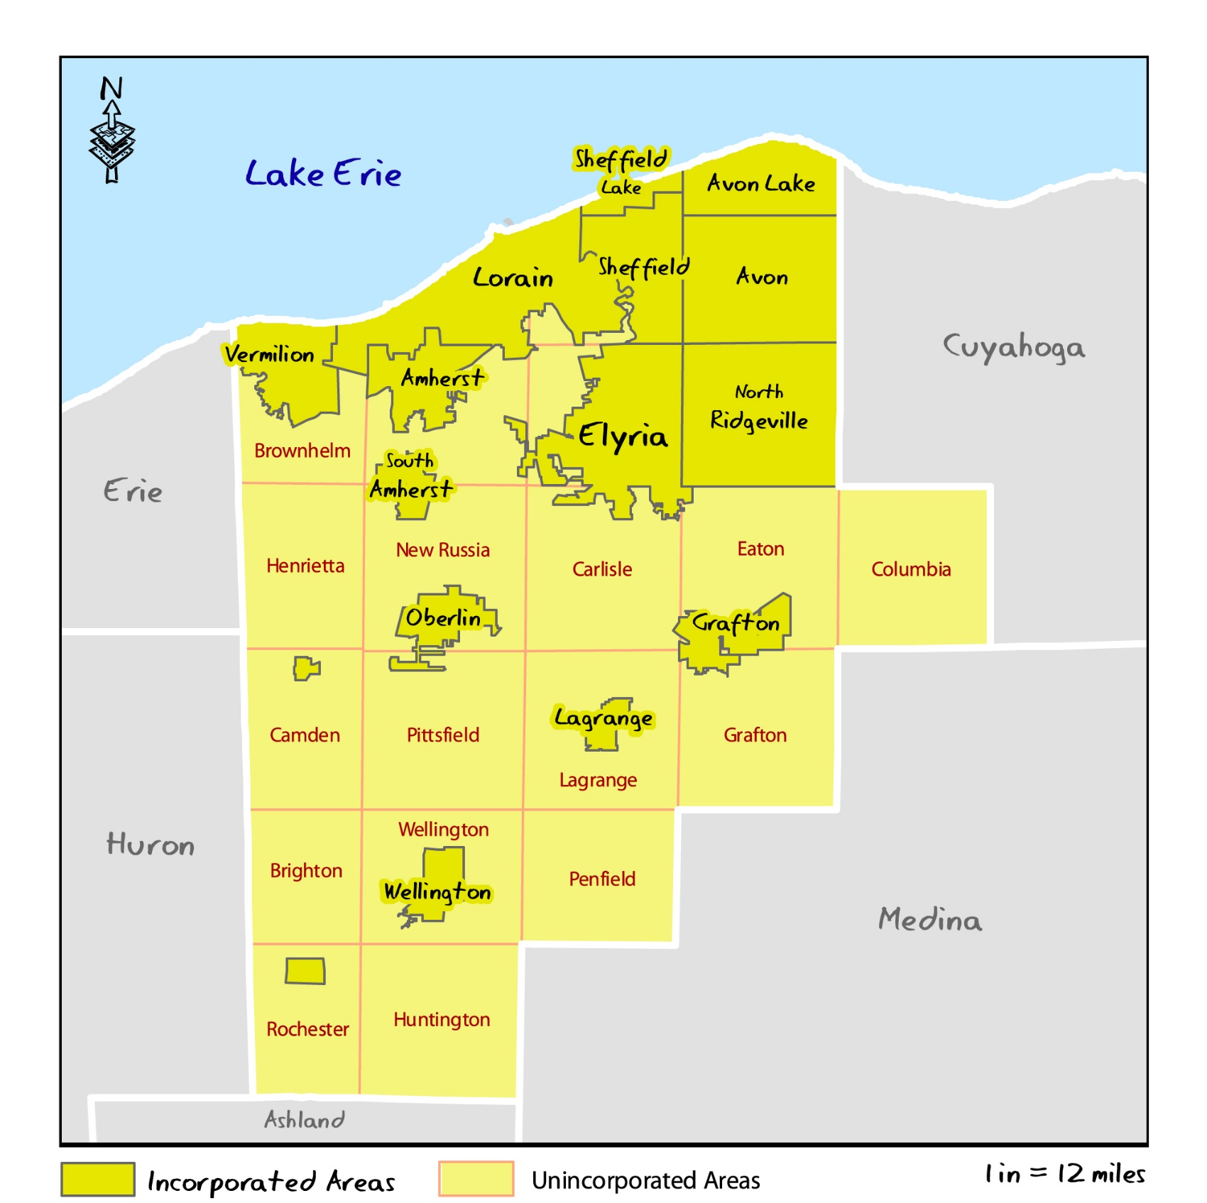

Zip Codes in Lorain County

Zip Code | City | County
44001 | Amherst | Lorain County
44001 | South Amherst | Lorain County
44011 | Avon | Lorain County
44012 | Avon Lake | Lorain County
44028 | Columbia Station | Lorain County
44035 | Elyria | Lorain County
44039 | North Ridgeville | Lorain County
44044 | Grafton | Lorain County
44049 | Kipton | Lorain County
44050 | Lagrange | Lorain County
44052 | Lorain | Lorain County
44053 | Lorain | Lorain County
44054 | Sheffield Village | Lorain County
44054 | Sheffield Lake | Lorain County
44055 | Lorain | Lorain County
44074 | Oberlin | Lorain County
44090 | Rochester | Lorain County
44090 | Wellington | Lorain County

